Chemistry 102 Name KEY

Martin Larter

Exam 2a Spring 2017

Multiple Choice (36 points)

Page 4 (17 points)

Page 5 (22 points)

Page 6 (25 points)

Total (100 points)

Percent Grade ____________

(26 points) Multiple Choice

1. The minimum combined kinetic energy reactant particles must possess in order for their collision to result in a reaction is called the

|  |  |
| --- | --- |
| 1. Dissociation energy. | 1. Collision energy. |
| 1. Activation energy. | 1. Orientation energy. |

1. Whether a reaction is exothermic or endothermic is determined by

|  |  |
| --- | --- |
| 1. The activation energy. | 1. The physical state of the reactants. |
| 1. Whether a catalyst is present. | 1. How reactant and product potential energies compare. |

1. Which of the following changes will decrease reaction rate for the chemical reaction

2CO + O2  2CO2

|  |  |
| --- | --- |
| 1. removing some CO from the reaction mixture | 1. raising the temperature of the reaction mixture |
| 1. adding some O2 to the reaction mixture | 1. adding a catalyst to the reaction mixture |

1. Catalysts are correctly characterized by each of the following statements except one. The exception is

|  |  |
| --- | --- |
| 1. They can be either solids, liquids or gases | 1. They are not consumed in a reaction |
| 1. They lower the activation energy for a reaction. | 1. They do not actively participate in a reaction. |

1. What type of reaction is illustrated in this diagram?

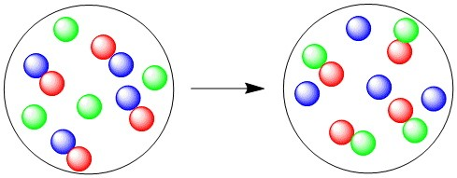

|  |  |
| --- | --- |
| 1. Combination | 1. Decomposition |
| 1. Single displacement | 1. Double displacement |

1. The relationship between the two molecules shown is



1. They are the same compound.
2. They are different compounds that are *cis-trans* isomers.
3. They are different compounds that are structural (constitutional) isomers.
4. They are different compounds that are stereoisomers.
5. They are different compounds that are not isomers
6. When an organic molecule gains hydrogens it is said to be:

|  |  |
| --- | --- |
| 1. oxidized | 1. reduced |
| 1. both oxidized and reduced | 1. neither oxidized or reduced |

1. Which pair of compounds can react to form a hemiacetal?

|  |  |
| --- | --- |
| 1. Carboxylic acid and alcohol | 1. Ether and aldehyde. |
| 1. Aldehyde and alcohol. | 1. Ether and carboxylic acid. |

1. Hydrolysis could be correctly described as the
2. Breaking of a long-chain compound into its subunits by adding water molecules to its structure between the subunits
3. Heating of a compound to drive off its excess water and concentrate its volume
4. Linking of two or more molecules by the removal of one or more water molecule
5. Constant removal of hydrogen atoms from the surface of a carbohydrate
6. Which of the following pairs of stereoisomers are related as enantiomers?

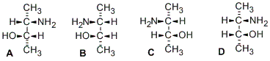

|  |  |  |
| --- | --- | --- |
| 1. A and B; C and D | 1. B and C; B and D | 1. A and D; B and C |
| 1. A and C; B and D | 1. none of them |  |

1. Which substance would be classified as a ketopentose?

|  |  |  |  |
| --- | --- | --- | --- |
|  |  |  |  |
| A | B | C | D |

1. Which of the following structures is that of an L-monosaccharide? C

|  |  |  |  |  |
| --- | --- | --- | --- | --- |
|  |  |  |  |  |

1. In which of the following carbohydrates are two different types of glycosidic linkages present?

|  |  |
| --- | --- |
| 1. glycogen | 1. lactose |
| 1. amylose | 1. more than one correct response |
| 1. no correct response |  |

For each of the reaction types on the left, select from the response list on the right the type of organic compound produced. Responses on the right may be used more than once or need not be used at all.

a) carboxylic acid

b) ketone

c) alcohol

d) no reaction occurs

|  |  |
| --- | --- |
| 1. a Oxidation of 2. d Oxidation of 3. b Oxidation of 4. c Reduction of 5. c Reduction of |  |

Problems

1. (6 points) Determine the molecular formula and how many primary, secondary, tertiary and quaternary carbons are present by writing the correct number next to the designation below.



Molecular Formula____C12H24_____________

How many: 1o _­­5__ 2o _3__ 3o __3_ 4o _1___ carbons

1. (7 points) Name the following structures

 

Name ________________________________ Name_________________________

1. (4 points) Draw structures *cis*-5-isopropyl-4,4-dimethyl-2-octene
2. (4 points) Place an asterisk (*) next to each stereocenter in the following molecule.



How many stereoisomers are possible for this molecule? __________________

1. (6 points) Label the six functional groups enclosed in boxes **include primary, secondary and tertiary on alcohols and alkyl halides**



|  |  |
| --- | --- |
|  |  |
|  |  |
|  |  |

1. (12 points) Draw the structures of the organic products of the following reactions.







1. (4 points) What does the following mean 18:3Δ9,12,15:
2. (7 points) Draw the Haworth projection for the ß-anomer mark the anomeric carbon with an asterisk of D-Sorbose.

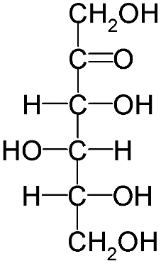

D-Sorbose

b) (4 points) Draw the Fischer projection for L-Sorbose

1. (10 points) Answer the following questions regarding the following disaccharides that are labeled **A**, **B** and **C**.



a) Circle the acetals place squares around hemiacetals, which of the above disaccharides are reducing sugars?

___________________________

b) What type of glycocidic bond is present in carbohydrate **A**? ____________________

c) What type of glycocidic bond is present in carbohydrate **B**? _____________________

